|  |  |  |  |
| --- | --- | --- | --- |
|  | Bansilal Ramnath Agarwal Charitable Trust's  Vishwakarma Institute of Information Technology  **Department of**  **Artificial Intelligence and Data Science** | | |
| Name: Siddhesh Dilip Khairnar | | | |
| Class: SY | Division: B | | Roll No: 272028 |
| Semester: IV | | Academic Year: 2022-2023 | |
| Subject Name & Code: Software Engineering, ADUA22204 | | | |
| Title of Assignment: **Write the Goals, Requirements (Functional, Non-functional, User Interface) of your three CPS (Customer Problem Statement)** | | | |

Aim: **Write the Goals, Requirements (Functional, Non-functional, User Interface) of your three CPS (Customer Problem Statement)**

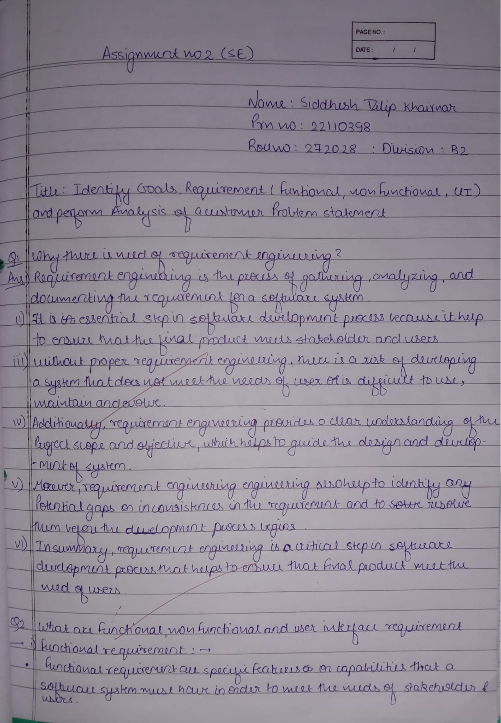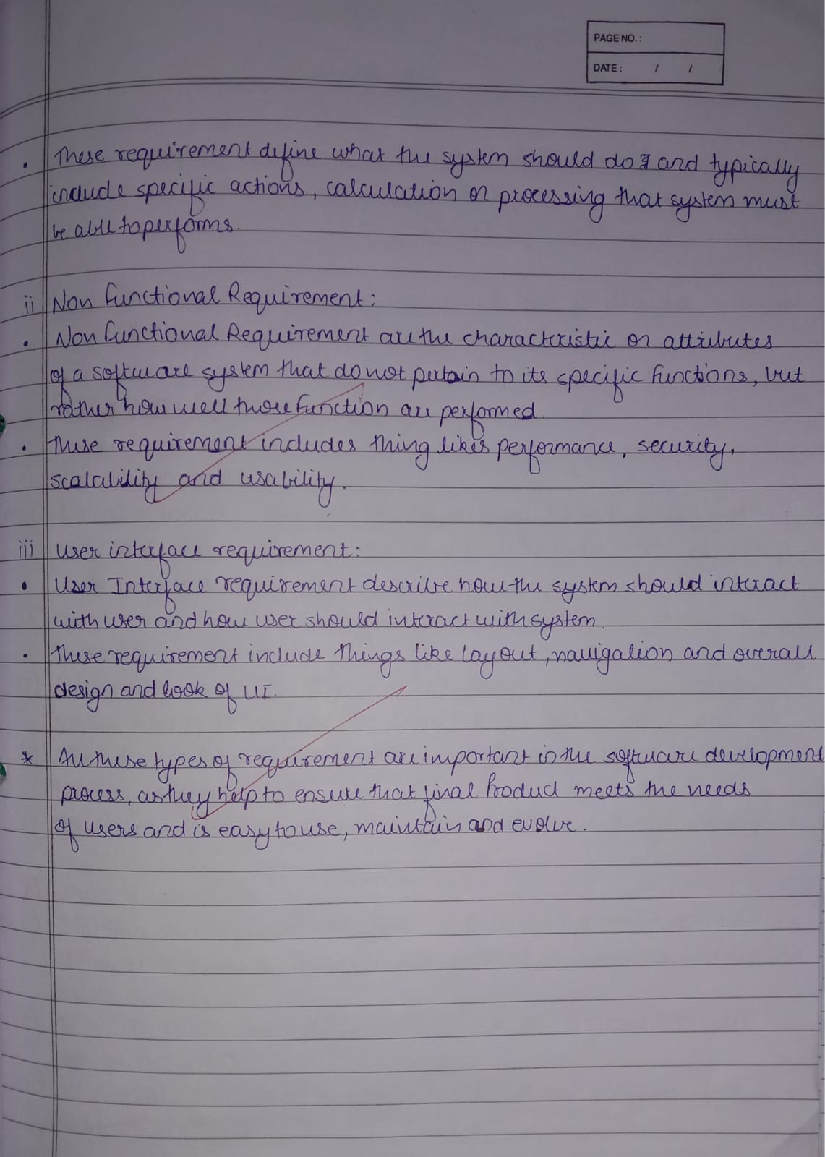

CP (I): Customer feels insecure in transaction through online mode to book ticket of park.

Goal: To build and deploy secure system for easy transaction.

Functional:

1. System must contain function of Transaction correction, adjustment and cancellation.
2. System must able to send OTP, notification alerting regarding money transfer has been detected

Non-Functional:

* 1. System must not disclose information of user like account number, bank detail etc.
  2. System must be quick and responsive.
  3. System must be secure and protected.

UI:

1. Interactive design.
2. Easy to use.
3. Must able to handle many people at same time.

CP (II): Student are trying to learn various course in online mode but content website is not responsive.

Goal: We will build a responsive website.

Functional:

1. Our website should contain latest technology and must stay updated frequently.
2. It should have a proper notification message which will pop up before opening any file or any course.

Non-Functional:

1. It should refresh continuously without disturbing user.
2. It must have access to the computer files and browsers so that student must able to upload their assignment.
3. Student must able to see updated detail easily and quickly.

UI:

1. Interactive design.
2. Easy to use.
3. Interactive video player must be used in video.

CP (III): Scientist is researching on topic but unable to find proper detail of concept.

Goal: Make a website and android application containing all blog and project related information.

Functional:

1. Our system will take input of project requirement and bases upon that will give suggestion.
2. Our system will also suggest the scientist that in which area he can apply their project.

Non-Functional:

1. System should able to handle many users at a time.
2. It should individually act with that user.

UI:

1. Easy to use.
2. Small size.

Conclusion:

In this way, we can categories the functional, non-functional and UI. This will help to understand the CP easily.